# FeederWatch (Ornithology for kids) andersoncountylibrary_logo

Objectives: To introduce children to the study of birds

To make a bird feeder inexpensively

To learn to identify the South Carolina state bird, the Carolina wren

Materials: 1 large pine cone whose scales have opened (see below).

Peanut butter.

Bird seed. Sunflower seeds for birds attract the most variety of species. Usually available at garden stores like Tractor Supply.

Twine – 30 inches.

Spoon or plastic knife for spreading peanut butter.

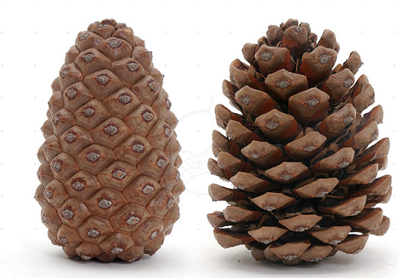

Good Better

Procedure:

* Cut a piece of twine about 30 – 36 inches long. Careful, pine cones can be prickly!
* Tie the twine around the pine cone.
* Spread peanut butter all over the pine cone.
* Roll peanut butter pine cone in bird seed.
* Tie your new bird feeder up and begin to watch for birds to come to their new “restaurant.”
* If you see the following bird, it is a Carolina wren, the South Carolina state bird.

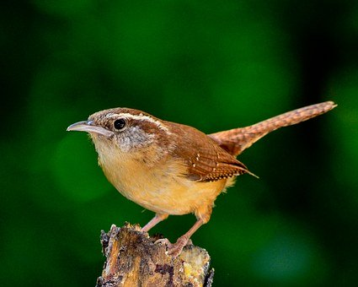

Carolina wrens have brown back and wing feathers. Their breast feathers are a yellowish tan color, and they have a distinctive white “eyebrow” over each eye.

The Carolina wren became the state bird in 1948. It lives in all areas of South Carolina. It measures about 5 inches (13 centimeters) long, and weigh less than one ounce.

Photo credit: <https://pixabay.com/images/search/carolina%20wren/>

***About FeederWatch***

The Anderson County Library is collaborating with Cornell University to bring you an ornithology program for all ages called FeederWatch.

FeederWatch is the collaboration of thousands of participants of all ages that spot and count birds in their area and report their findings, in this case to the library. Our librarians will then tally them up and report the results to Cornell University.

Project FeederWatch turns your love of feeding birds into scientific discoveries. FeederWatch is a November-April survey of birds that visit backyards, nature centers, community areas, and other locales in North America. You don’t even need to buy a feeder or pay the membership fee if you use the library’s resources.

Anyone interested in birds can participate. The library has paid the cost. FeederWatch is conducted by people of all skill levels and backgrounds, including children, families, individuals, classrooms, retired persons, youth groups, nature centers, and bird clubs. Cornell has sent us everything else you need to get started identifying birds.

This program will take place at the Anderson County Main Library from November 14, 2020, through April 9, 2021.

Exact days and times will be determined and posted on our website and Facebook page.