**The Curious Minded Tween**

**December Challenge: Let’s Make Oxygen!**

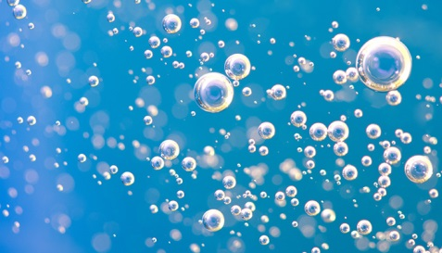

We have been talking about breathing and how vital it is to all life forms. Oxygen is the catalyst for life on earth. This challenge will see how effective you are at creating your own oxygen! Once done, take a picture of the final experiment and tell us what conclusions you have come too.

**Equipment:**

* Large see through jar
* Water
* One leaf
* Sunshine
* A magnifying glass

**Instructions:**

* Make sure it’s a sunny day
* Fill your jar all the way to the top with water.
* Place your leave in the jar with the water.
* Put the jar outdoors, and put it directly in the path of the sun, so it can beam on the jar.
* Leave the jar in the sunshine for several hours before looking with the magnifying glass.

**Conclusion:**

After several hours, look at the leave and write down what you see, (you should see little bubbles on the leave. When you see them, it will confirm that leaves are oxygen producing agents. The leave is using the sunlight and carbon dioxide to make its food. The carbon dioxide enters the underside of the leaves, uses the sunlight to make sugar which gives it energy! Oxygen is released from the leave as a BY-PRODUCT of this process. SO COOL!!