DIY Rain Gauge Instructions

CoCoRaHS for Schools Educational Video

<https://www.youtube.com/watch?v=_RAld4kZ2d0&feature=youtu.be>

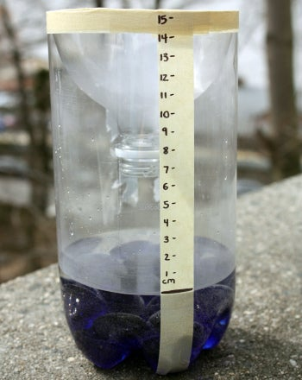

**Materials: (materials underlined are in the Grab N Go Kits)**

* Empty two-liter plastic bottle
* Scissors
* A few handfuls of clean pebbles, gravel, or marbles
* Masking tape
* Paper clips
* Water
* Ruler
* Permanent marker
* Rainy weather
* Paper and pencil

**Experiment:**

1. Carefully use the scissors to cut the top of the bottle off at the point where it becomes wide. (Note: you are going to fit the top part you cut into the bottom part upside down, try to cut the edges as smoothly as possible.)
2. Put the pebbles in the bottom of the bottle—these will help keep it from getting blown over if it’s windy. (Note: if you want you can put the bottle on a wooden post, or tree, fence… just make sure its sturdy and that there is are no branches or inhibitors for the rain to fall into the rain gauge.)
3. Turn the top of the bottle upside down, take the cap off. It’s going to act like a funnel ( Note: have four pieces of tape or use the paper clips to secure the lid to the bottle, if you don’t cut the top of the bottle at the exact point, it may fall in, so secure it with four pieces of tape before you tape the entire thing.) — place it in the bottom part of the bottle, pointing downward. Line up the cut edges and tape them together so the top part is held firmly in place.
4. Use a long piece of tape to make a straight vertical line from the top edge of the bottle to the bottom. Use the marker to draw a line on the vertical piece of tape where the bottle evens out, this will be the bottom of your rain gauge.
5. Set the ruler against the vertical tape so that the “0” line lines up with the bottom mark. Now you can decide: either tape the ruler to the bottle and keep it there or use the marker to mark every quarter-inch (or, if you want to get fancy, every eighth-inch) along the piece of tape. Then label the inches from bottom to top. (Alternatively, you can mark centimeters and half-centimeters instead.)
6. Set the bottle on a level surface and pour some water in until it reaches the bottom mark. Your rain gauge is now ready to go!
7. Put the rain gauge outdoors—you’ll need to pick a really good spot! You want somewhere level that’s open to the sky and that’s not likely to get too windy, where the gauge isn’t likely to be disturbed. There shouldn’t be anything hanging over the gauge that could either block any rain or make extra raindrops drip into the bottle (like a tree or a power line or the edge of a roof).
8. Pay attention to the forecast. On a day that you’re likely to get rain, make sure the water in the bottom hasn’t evaporated below your bottom mark; if it has, refill it to that mark.
9. If it rains within 24 hours, check your gauge and see how high the water is now. That’s how much rain has fallen in the last day! On your piece of paper, make a note of the date and the amount of rain. Then read the newspaper or go online and find out the official amount of rainfall in your area for the day and make a note of it—see how closely your figure matches the official one!
10. Repeat steps 7-9 for several rainy days.

References:*What’s Up? 45 Hands-On Science Experiments That Explore Weather*, by B. K. Hixson, pp. 82-83 (Loose in the Lab Science Series, 2003).