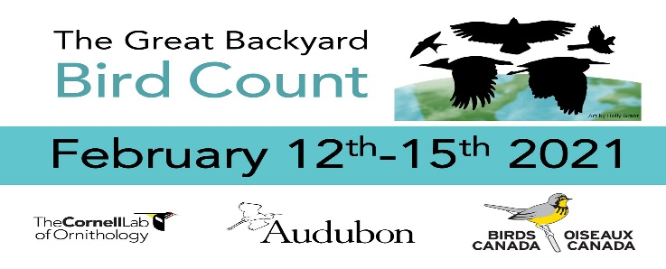Great Backyard Bird Count

What is the Great Backyard Bird Count? https://www.birdcount.org/

How Can I Participate in the GBBC? https://www.birdcount.org/participate/

DIY Bird Feeder Grab n Go Instructions: <https://www.thespruce.com/make-a-plastic-bottle-bird-feeder-386547>

How to Participate

Participating is easy, fun to do alone, or with others, and can be done anywhere you find birds.

**Choose the easiest way for you to share your birds:**

* Identify birds with [**Merlin Bird ID app**](https://merlinbirdid.page.link/download) and add sightings to your list
* Use the **[eBird Mobile app](https://ebird.page.link/download)**
* Enter your bird list on the **[eBird website](https://ebird.org/home?__hstc=64079792.743587d59aa6febc5911a90ce792b65e.1611074136102.1611074136102.1611758984508.2&__hssc=64079792.2.1611758984508&__hsfp=3980002155)** (Desktop/laptop)

All you need is a free Cornell Lab account to participate. This account is shared with Merlin, eBird, Project FeederWatch and other projects at the Cornell Lab of Ornithology. If you already have an account please use the same username and password for submitting your bird list for the Great Backyard Bird Count.

We recommend **observing birds for at least fifteen minutes**. [See this page for more counting instructions](https://www.birdcount.org/tools/counting-instructions/).

**It’s That Easy!**  
Submit one or more lists over the four days of counting and you become a contributing citizen scientist ([community scientist](https://www.audubon.org/about/edi)). All eBird entries and saved Merlin Bird IDs over the four days contribute to the Great Backyard Bird Count.

**Merlin Bird ID app**

**New to birding or using eBird?** Merlin is **FREE** and is the easiest way to get started.

With just a few simple questions, Merlin Bird ID can guide you through a list of possible matches. When you tap “This is my bird!” and save your sighting, you are participating in the Great Backyard Bird Count!

Merlin covers bird species from **7 continents** and is available in **8 languages**.

**eBird Mobile app**

If you are already using eBird to track your birding activity, the **FREE**eBird Mobile app is a fast way to enter your bird lists right from the palm of your hand.

**Desktop or Laptop**

Navigate directly to the website to get started.  
Unfamiliar with using eBird on a computer? [Try this guide](https://ebird.freshdesk.com/en/support/solutions/articles/48001158707)

How to Make DIY Bird Feeder