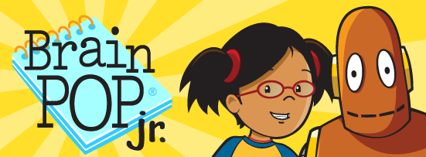

BrainPop Jr. The app that makes learning fun!

This week’s BrainPop Jr. activity is brought to you by the Anderson County Library!

Go to www.andersonlibrary.org. Select Services. Select For Children. Scroll down and select Kids’ Databases. Select BrainPop Jr. The username is **discus2021** and the password is **think1!**

Select any of the educational activities that would benefit your child. If your child likes video games, Select Game Up for cool math video games.

Congratulations! You have just completed this week’s activity!