**Answer key**

**Across**

1. Claw

3. Norbert

5. Fantasy

6. Books

8. Wings

**Down**

1. Castles

2. Fire

4. Knights

7. Sword

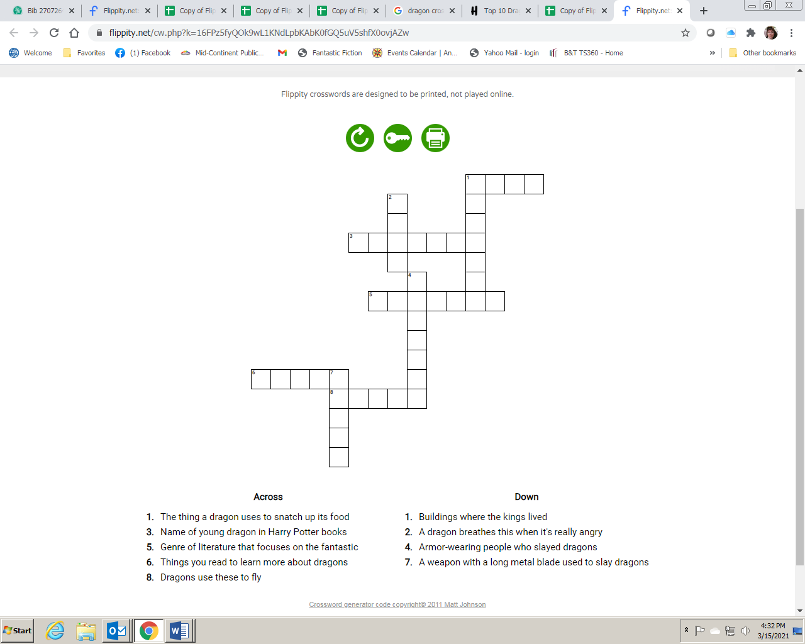

Roaring Dragon Crossword Puzzle